**Air Quality Lesson Plan**

**London Borough of Lewisham**

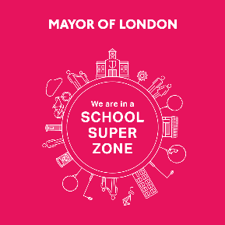

**MP Smarter Travel**

Laurence House

Catford Road

London SE6 4RU

January 2023

August 2020

# Air Quality Lesson Plan

**Air Quality**

[Government policy documents](https://assets.publishing.service.gov.uk/government/uploads/system/uploads/attachment_data/file/1124738/chief-medical-officers-annual-report-air-pollution-dec-2022.pdf) have highlighted a call to action around air pollution. It is important for children to learn about the extend of air pollution and its impacts, as well as how they and their families can help to reduce air pollution.

**Lesson Ideas**

These activities could be used as a double lesson or within a series of lessons focusing more in-depth learning on specific aspects of air pollution.

The presentation will introduce the pupils to the topic of air pollution. Discussions will be had around causes, effects and solutions to air pollution.

The final activity will consolidate children’s learning about the causes and effects of air pollution, potential solutions and the importance of action to reduce air pollution.

**Prior Learning**

Lesson applicable for KS1-KS2 children.

Children should be comfortable with persuasive writing or poster making.

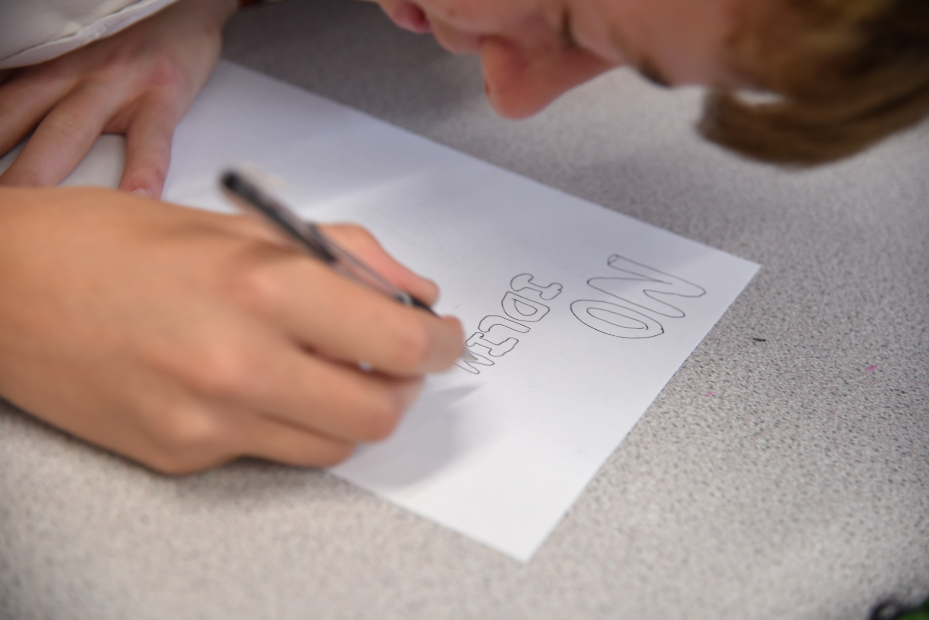

# Links to National Curriculum

Air pollution aligns with the national curriculum for pupils KS1, KS2. Education around pollutant gases and particulate matter align with key science themes. Ideas around environmental change aligns with themes within human and physical geography.

A list of [curriculum links](https://www.gov.uk/national-curriculum/key-stage-1-and-2) by subject are highlighted below:

**Science**

* Properties and changes of materials
* States of matter: Compare and group materials together, according to whether they are solids, liquids or gases
* Develop understanding of the nature, processes and methods of science through different types of science enquiries that help them to answer scientific questions about the world around them
* Reporting and presenting findings from enquiries, including conclusions, causal relationships and explanations of and degree of trust in results, in oral and written forms such as displays and other presentations
* Identifying scientific evidence that has been used to support or refute ideas or arguments
* Asking relevant questions and using different types of scientific enquiries to answer them
* Pupils are equipped with the scientific knowledge required to understand the uses and implications of science, today and for the future
* The study of animals including humans: find out about and describe the basic needs of animals, including humans, for survival (water, food and air)
* Living things and their habitats: recognise that environments can change which can sometimes pose dangers to living things

**Geography**

* Recognise that environments can change and that this can sometimes pose dangers to living things.
* Pupils should explore examples of human impact (both positive and negative) on environments
* Describe and understand key aspects of physical geography, including: climate zones, biomes and vegetation belts, rivers, mountains, volcanoes and earthquakes, and the water cycle
* Pupils should explore examples of human impact (both positive and negative) on environments

# Lesson Layout

## A description of different elements of the lesson.

|  |  |  |
| --- | --- | --- |
| **Learning objectives & Success Criteria** | **Lesson delivery tasks** | **Resources** |
| **Learning Objective:**  To understand the issue of London’s air pollution.  **Success Criteria:**  I can say what air pollution is.  I can say what the main causes of air pollution is.  I can say what the effects on people are.  I can say what some of the solutions might be. | **Main teaching:**  Display slide 2: ‘**What gases are in the air in Lewisham?’** Ask childrenif they can name any gases in the air.  Display slide3: **‘What gases are in the air in Lewisham?’**  Introduce the idea that there are lots of different gases in our air, some that you might recognise and some not. Introduce chemical formulas and ask if children recognise any.  Display slide 4: ‘**What gases are in the air in Lewisham?’**  Name the gases that appear on the slides and suggest that pupils may be more familiar with these.  Ask the children which of these gases makes up most of the air we breathe in?  Display slide 5: ‘**What gas makes up most of the air?’**  Explain how we often hear a lot more about oxygen but nitrogen makes up such a large amount of our atmosphere. Explain that Nitrogen is an essential nutrient for sustaining life on Earth- plants need an adequate annual supply for proper growth and productivity.  Display slide 6: ‘**Why do we need safe, clean air?’**  Ask children to jog on the spot for one minute – set a timer. What they notice about their breathing?  Why is it faster? Why is it important that the air we breathe is clean?  Display slide 7: **‘Why do we care what is in the air?’**  Thinking about the previous activity, ask the children why we care about what is in the air?  Introduce breathing as a concept. What happens if there are things in the air that should not be there? What do we call it?  Display slide 8: **‘What is air pollution?’**  Introduce what is meant by air pollution.  Display slide 9: **‘What is air pollution?’**  Explain that pollution can come in two forms. Gases and particulates. Use the slide information to explain particulates.  Display slide 10: **‘What are some examples of polluting particles in Lewisham?’**  Explain different types of particulates on the screen in more detail.  Display slide 11: **‘What gases are in the air?**  Reflect back to the discussion earlier about the gases that make up the air we breathe. Explain air pollution is when the balance of gases is disrupted, with too much of some gases being bad for us.  Display slide 12: **‘What gases are pollutants?**  Introduce the main pollutant gases.  Display slide 13: **‘Which of these creates the most pollution in London?’**  Highlight that human actions can cause pollutant gases.  Display slide 14: **‘Which of these creates the most pollution in London?’**  Explain which human actions create the most pollution in London.  Display slide 15: **‘Which of these creates 17% of particulate matter pollution in London?’**  Highlight fireplaces, from wood/ coal burning in homes, and cooking on gas hobs as a main cause for particulate matter in London.  Display slide 16: **‘How do cars create particulate pollution’**  Explain how cars cause particulate pollution in multiple ways.  Display slide 17: **‘How is nitrogen dioxide created in a car?’**  Give more information about Nitrogen Dioxide, how it is a main cause of pollution and how humans increase the amount of nitrogen dioxide pollution  Display slide 18: **‘How is nitrogen dioxide created in a car’?**  Explain how nitrogen dioxide is created in a car- the engine and exhaust pipe.  Display slide 19: **‘Engine Idling’**  Explain what engine idling is, why people may do it, and the polluting impact.  Display slide 20: **‘How can we tell when somewhere is polluted?’**  Introduce ideas around how pollution can be detected. Use Lewisham specific examples, including monitoring sites and Lewisham Air app.  Display slide 21: **‘Monitoring air pollution’**  Introduce diffusion tubes as a way of measuring nitrogen dioxide and sensors as a way of measuring gases and particulates. Use Lewisham diffusion tube and sensor locations as an example. Introduce government policy around air pollution concentration limits. Do you have any diffusion tubes in the school to show to the class?  Display slide 22: **‘What can pollution do to our body?’**  Introduce how pollution can affects different parts of our body, such as lungs, heart and brain. Explain what types of illnesses may occur.  Display slide 23: **‘Asthma’**  Introduce asthma- what it is, how common it is, and the causes.  Display slide 24: **‘Where is pollution worst?’**  Demonstrate spatial variation in NO2 pollution in London. Ask children to analyse the map- where pollution is worse and local contributors on the map that impact this.  Display slide 25: **‘Air pollution in Lewisham’**  Show air pollution in Lewisham.  Display slide 26: **‘Focus areas in Lewisham’**  Explain that air quality focus areas are where air pollution is being monitored based on different pollution levels in Lewisham. How can we help Lewisham Council with this air pollution reduction work?  Display slide 27: **‘Indoor air pollution’**  Explain that air pollution also occurs indoors. Introduce the causes and impacts of indoor air pollution.  Display slide 28: **‘How do we reduce air pollution and our exposure to it?**  Introduce the idea of individual interventions that pupils and their families can do to reduce air pollution. Many of them may already be doing some.  Display slide 29: **‘Lewisham Clean air pledge’**  Introduce the clean air pledge.  Display slide 30: **‘Lewisham air quality accreditation’**  Introduce the Lewisham air quality accreditation scheme.  Display slide 31: **‘Idling Action pledge’**  Introduce the idling action pledge  **Activity:**  Display slide 32: **‘Activity’.**  Ask the children to write a formal letter to the Mayor of London, outlining the main causes and effects of air pollution, and persuading him solutions to implement. Some children could use the template “I need clean air because I like...” to draw a poster, showing the things they do in their lives that are affected by air pollution. Petition posters can be made | **Equipment:**  Air quality presentation  Timer  Paper  Coloured pens/ pencils  **Useful information:**  [Lewisham Council- air quality website](https://lewisham.gov.uk/airquality)  [Lewisham Council- air quality app](https://lewisham.gov.uk/myservices/environment/air-pollution/download-our-air-quality-app)  [Lewisham Council community asthma service website](https://www.lewishamandgreenwich.nhs.uk/childrens-community-asthma-service/)  [DEFRA- air quality standard limits](https://uk-air.defra.gov.uk/air-pollution/uk-eu-limits)  [Lewisham Council- Clean Air pledge](https://lewisham.gov.uk/myservices/environment/air-pollution/sign-our-clean-air-pledge)  [Idling Action pledge](https://idlingaction.london/)  [TfL STARS](https://stars.tfl.gov.uk/) |